A CASE-STUDY BASED REPORT
ON
CineMatch: A Content-Based and Collaborative Movie Recommendation Engine
submitted in partial fulfilment of the requirements for the Course
MACHINE LEARNING
BACHELOR OF TECHNOLOGY
A.Y.: 2026–27

by
P. YASASRI 2520030373
G. JAHNAVI 2520030483
Under the Esteemed guidance of
Dr. Raghavendra
Assistant Professor, Department of CSE




INDEX
Abstract
Introduction
Background
Motivation for the Project
Overview of the Work Carried Out
Scope and Responsible-Use Statement
Problem Statement
Case-Study Scenario
Central Case-Study Question
Formal Problem Definition
Objectives that Guide the Study
Assumptions and Limitations
Dataset and Exploratory Data Analysis
About the Dataset
Purpose of EDA
Preparation Steps Actually Performed
EDA Exploration - Implementation
Summary of EDA Findings
Algorithm Selection and Implementation
Conclusion

Abstract
CineMatch is a machine-learning-based application that helps users discover movies using two recommendation approaches. Content-based filtering uses movie metadata such as genres, keywords, cast, and plot overview. These text fields are combined and converted into numerical features using Term Frequency–Inverse Document Frequency (TF-IDF), and cosine similarity ranks movies with similar content. Collaborative filtering uses historical user ratings from a MovieLens-format dataset. In the implemented item-based version, each movie is represented by its rating pattern across users, and cosine similarity identifies movies with similar rating patterns. The application is built with Python, Pandas, scikit-learn, SciPy, and Streamlit. Users choose a recommendation method and a movie, then receive a ranked list of suggestions. Development tests show that both methods return recommendations for selected titles such as Spider-Man and Toy Story. These examples demonstrate functionality, not a formal accuracy benchmark; recommendation quality depends on dataset coverage, metadata quality, and rating patterns. The project illustrates data preparation, feature engineering, similarity-based ranking, and deployment of a recommender-system prototype.

1. Introduction

1.1 Background
Online streaming services offer large movie catalogues, making it difficult for viewers to decide what to watch. A recommender system reduces this effort by ranking titles that may match a viewer’s interests. CineMatch is a student prototype demonstrating content-based filtering and collaborative filtering.

1.2 Motivation for the Project
A single recommendation strategy has limitations. Content-based filtering recommends films with similar metadata but can over-focus on shared keywords. Collaborative filtering can discover relationships in rating behaviour, but it depends on sufficient ratings and may suggest films whose stories differ from the selected title. Implementing both methods makes these differences visible.

1.3 Overview of Work Carried Out
The project loads movie metadata and rating data, preprocesses text fields, constructs feature representations, calculates similarity, ranks candidate movies, and presents recommendations through a Streamlit interface. The user chooses a method, selects a movie, and requests recommendations. Content-based data uses TMDB 5000 Movies and Credits CSV files; collaborative filtering uses MovieLens-format movies and ratings CSV files.

1.4 Scope and Responsible-Use Statement
CineMatch is an educational prototype, not a production streaming service. Suggestions are based on supplied datasets and should not be interpreted as objective measures of movie quality. Dataset licensing and attribution should be respected when distributing the application.

2. Problem Statement

2.1 Case-Study Scenario
A viewer likes a particular film but does not know what to watch next. Searching through many titles manually is time-consuming. The application accepts a selected movie and returns a short, ranked list of candidates.

2.2 Central Case-Study Question
How can movie metadata and historical user ratings be used to generate useful movie recommendations, and how do content-based and collaborative filtering differ in the suggestions they produce?

2.3 Formal Problem Definition
Input: a selected movie title, movie metadata, and/or user–movie ratings. Processing: represent information numerically, calculate similarity scores, exclude the selected movie, and rank candidates. Output: up to five recommended movie titles. Recommendations are limited by dataset coverage, quality, and sparsity.

Objectives
- Build a working Streamlit interface.
- Use genres, keywords, cast, and overview text for content-based filtering.
- Apply TF-IDF and cosine similarity to rank content-similar movies.
- Use user–movie ratings for item-based collaborative filtering.
- Compare the behaviour and limitations of both approaches.
- Test multiple movie titles and document observed output.

2.5 Assumptions and Limitations
The CSV files are assumed to contain expected columns and valid movie identifiers. Exact-title matching can limit choices when titles differ between datasets or include release years. Collaborative recommendations depend on rating coverage and can be affected by sparse or noisy ratings. Formal evaluation with Precision@K, Recall@K, or NDCG@K has not yet been recorded; these are recommended for future evaluation.

3. Dataset and Exploratory Data Analysis

3.1 About the Dataset
Content-based component: TMDB 5000 Movies and TMDB 5000 Credits CSV files. The movie file includes fields such as title, genres, keywords, and overview; the credits file supplies cast information. Collaborative component: MovieLens-format movies.csv and ratings.csv files, containing movie titles/IDs and user ratings. These are separate datasets, so available dropdown choices may differ.

3.2 Purpose of EDA
Exploratory data analysis checks input-file structure, missing text, title coverage, rating distributions, and the number of ratings supporting each movie. Missing metadata and sparse ratings can affect recommendations.

3.3 Preparation Steps
The content-based code loads movie and credits files, selects title and cast columns, and merges cast information by title. Genre, keyword, and cast strings are parsed into names; missing overview values are replaced with empty strings. The fields are combined, with genres and keywords given additional influence by repeating them before vectorization. The collaborative code maps movie and user IDs to matrix indices and builds a sparse movie–user rating matrix.

3.4 EDA Implementation and Findings
Before submission, confirm the CSV files exist, inspect column names and row counts, check duplicate or missing titles, verify that ratings reference known movie IDs, and examine rating counts per movie. Screenshots confirm that selected titles can be processed and recommendations displayed. Exact dataset statistics are not claimed here because they should be recorded from the team's local files.

3.5 Summary of Findings
TMDB provides descriptive movie features, while MovieLens-format ratings provide user-behaviour signals. Therefore, the two methods can show different title choices. Dataset coverage, title matching, missing metadata, and rating sparsity influence the rankings.

4. Algorithm Selection and Implementation

4.1 System Workflow

1.Open the CineMatch Streamlit application.

2. Choose Content-Based or Collaborative Filtering.

3. Select a movie from the relevant dataset.

4. The selected recommendation function identifies the movie.

5. The model computes similarity and ranks candidates.

6. The application displays up to five recommendations.4.2 Content-Based Filtering
The model combines genres, keywords, the first three cast names, and overview text. TfidfVectorizer converts text into term-weighted features and removes common English stop words. Cosine similarity compares movie vectors. Candidates are sorted by similarity, and the selected movie is excluded. Repeating genre and keyword text gives those fields additional influence.

4.3 Collaborative Filtering
The item-based model builds a sparse matrix with movies as rows, users as columns, and observed ratings as values. Each movie is represented by its rating pattern across users. Cosine similarity compares the selected movie with other movie vectors. The selected title is excluded, movies with fewer than three ratings are filtered out, and candidates with positive similarity are ranked. This method compares rating patterns rather than plot or genre directly.

4.4 Technologies Used
Python; Pandas for CSV processing; NumPy for numerical arrays; scikit-learn for TF-IDF and cosine similarity; SciPy for sparse matrices; Streamlit for the interactive interface.

4.5 Algorithm Selection Rationale
TF-IDF is suitable for turning movie descriptions and metadata into weighted numerical features. Cosine similarity is a straightforward measure for comparing high-dimensional vectors. Item-based collaborative filtering uses audience-rating behaviour to find movies with similar rating patterns. Both approaches are understandable and feasible for a student project.

4.6 Pseudocode
CONTENT-BASED: Load movies and credits; merge cast; parse genres, keywords, and cast; combine text; fit TF-IDF; calculate similarity; locate selected movie; sort candidates; exclude selected title; return top N.
COLLABORATIVE: Load movies and ratings; map movie/user IDs; build sparse matrix; locate selected movie; calculate cosine similarity with other movie vectors; exclude selected title; filter low-rating-count candidates; sort by similarity; return top N.

4.7 Complexity and Practical Considerations
A full pairwise content similarity matrix can require quadratic storage in the number of movies. For larger catalogues, calculate similarities on demand or use sparse operations. Sparse ratings matrices reduce memory use for collaborative filtering; caching and precomputation can improve response time.

5. Results and Discussion

5.1 Functional Results
The Streamlit application launches locally and displays the CineMatch interface. In the demonstrated content-based test for Spider-Man, results included Spider-Man 3, Avengers: Age of Ultron, X-Men, and Spider-Man 2. In the collaborative test for Spider-Man (2002), results included Spider-Man 2 (2004), Star Wars: Episode II – Attack of the Clones, Minority Report, X2: X-Men United, and X-Men. These are development examples, not a guarantee of fixed rankings across different data or code versions.

5.2 Interpretation
Content-based results include direct sequels and superhero titles, broadly consistent with metadata similarity; a spider-related title can also appear because keyword overlap may influence scores. Collaborative results can include films with different plots because similarity is based on rating patterns. This demonstrates why the two approaches should be compared.

5.3 Evaluation Limitations
A functioning interface and plausible examples establish basic functionality but do not prove recommendation accuracy. No formal ground-truth evaluation or user study is reported. Future evaluation should use held-out ratings and metrics such as Precision@5, Recall@5, and NDCG@5, plus human relevance checks for content-based results.

5.4 Screenshots
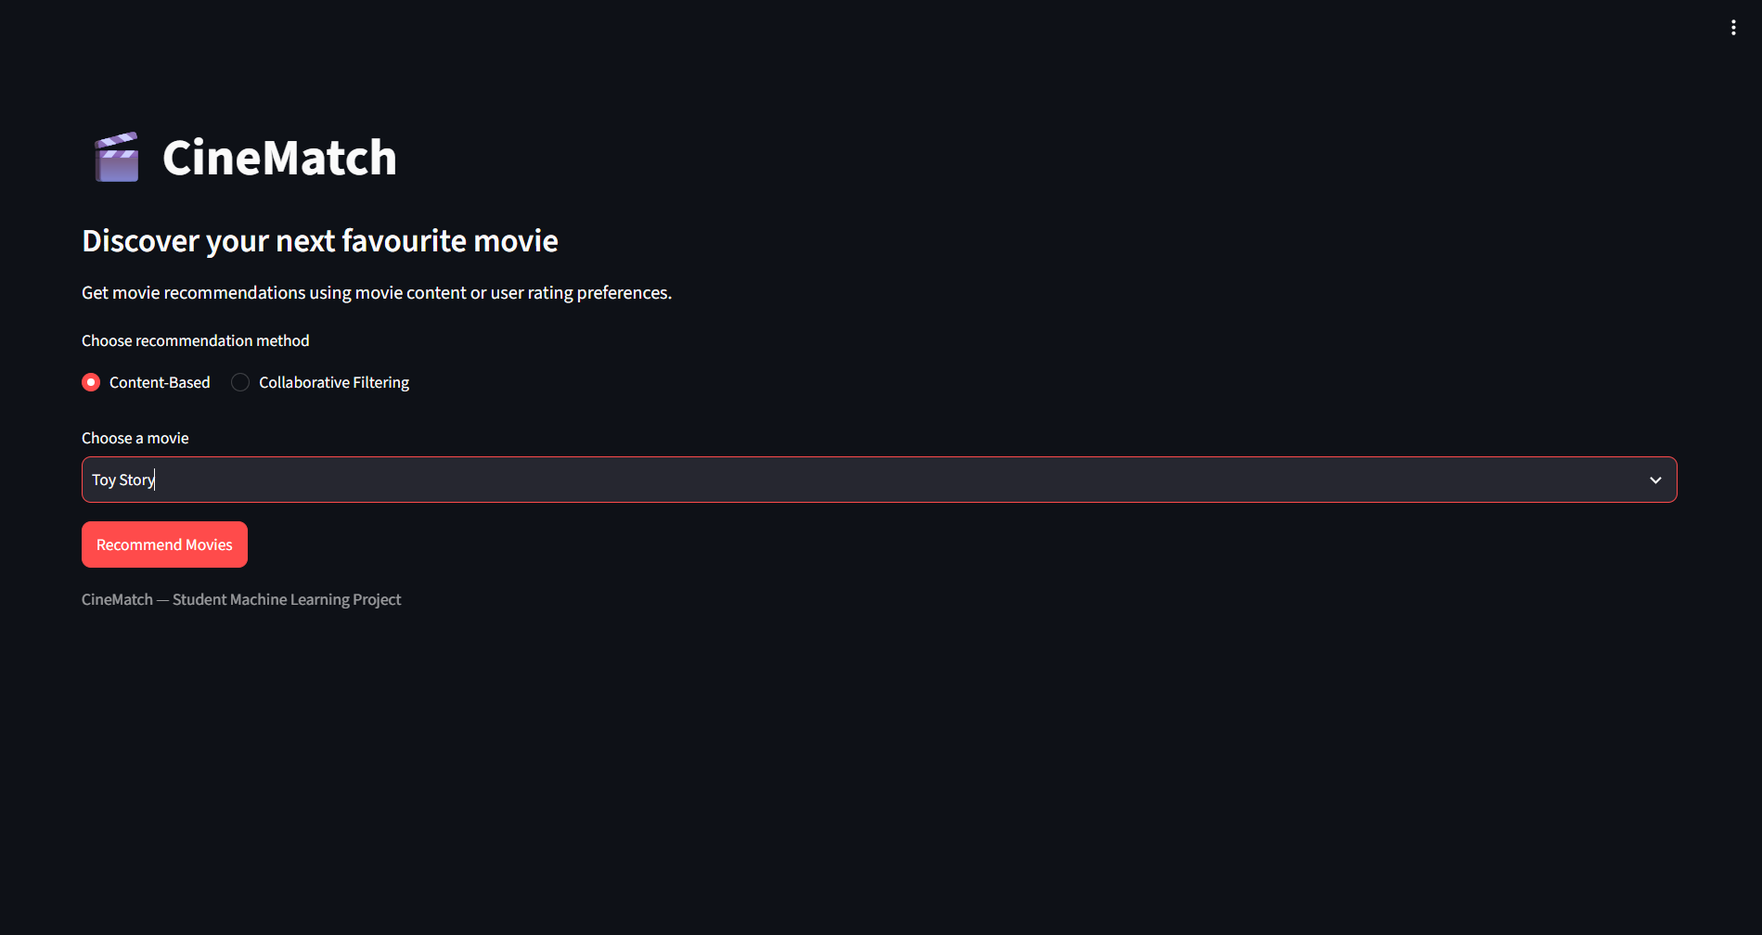
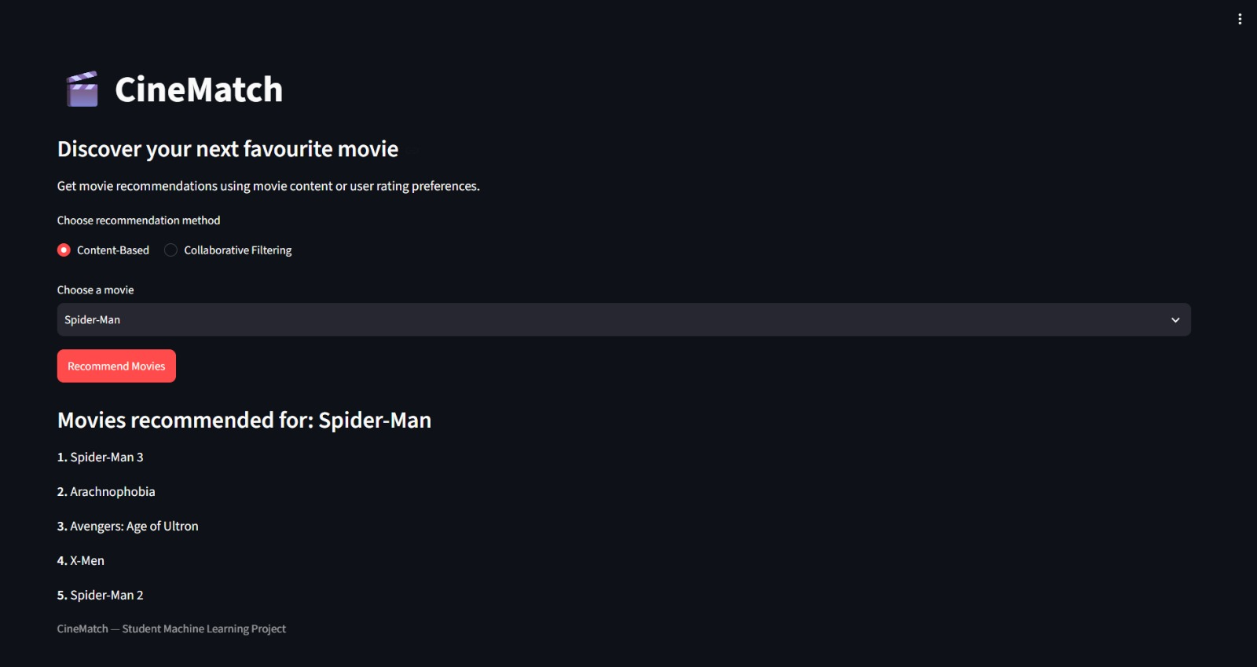

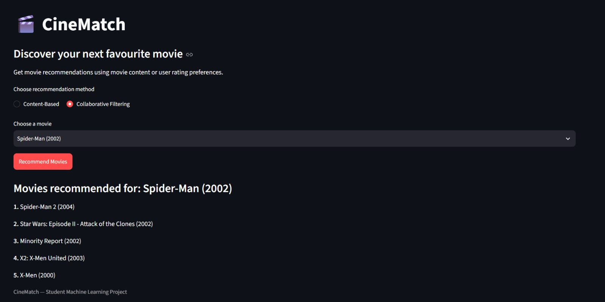

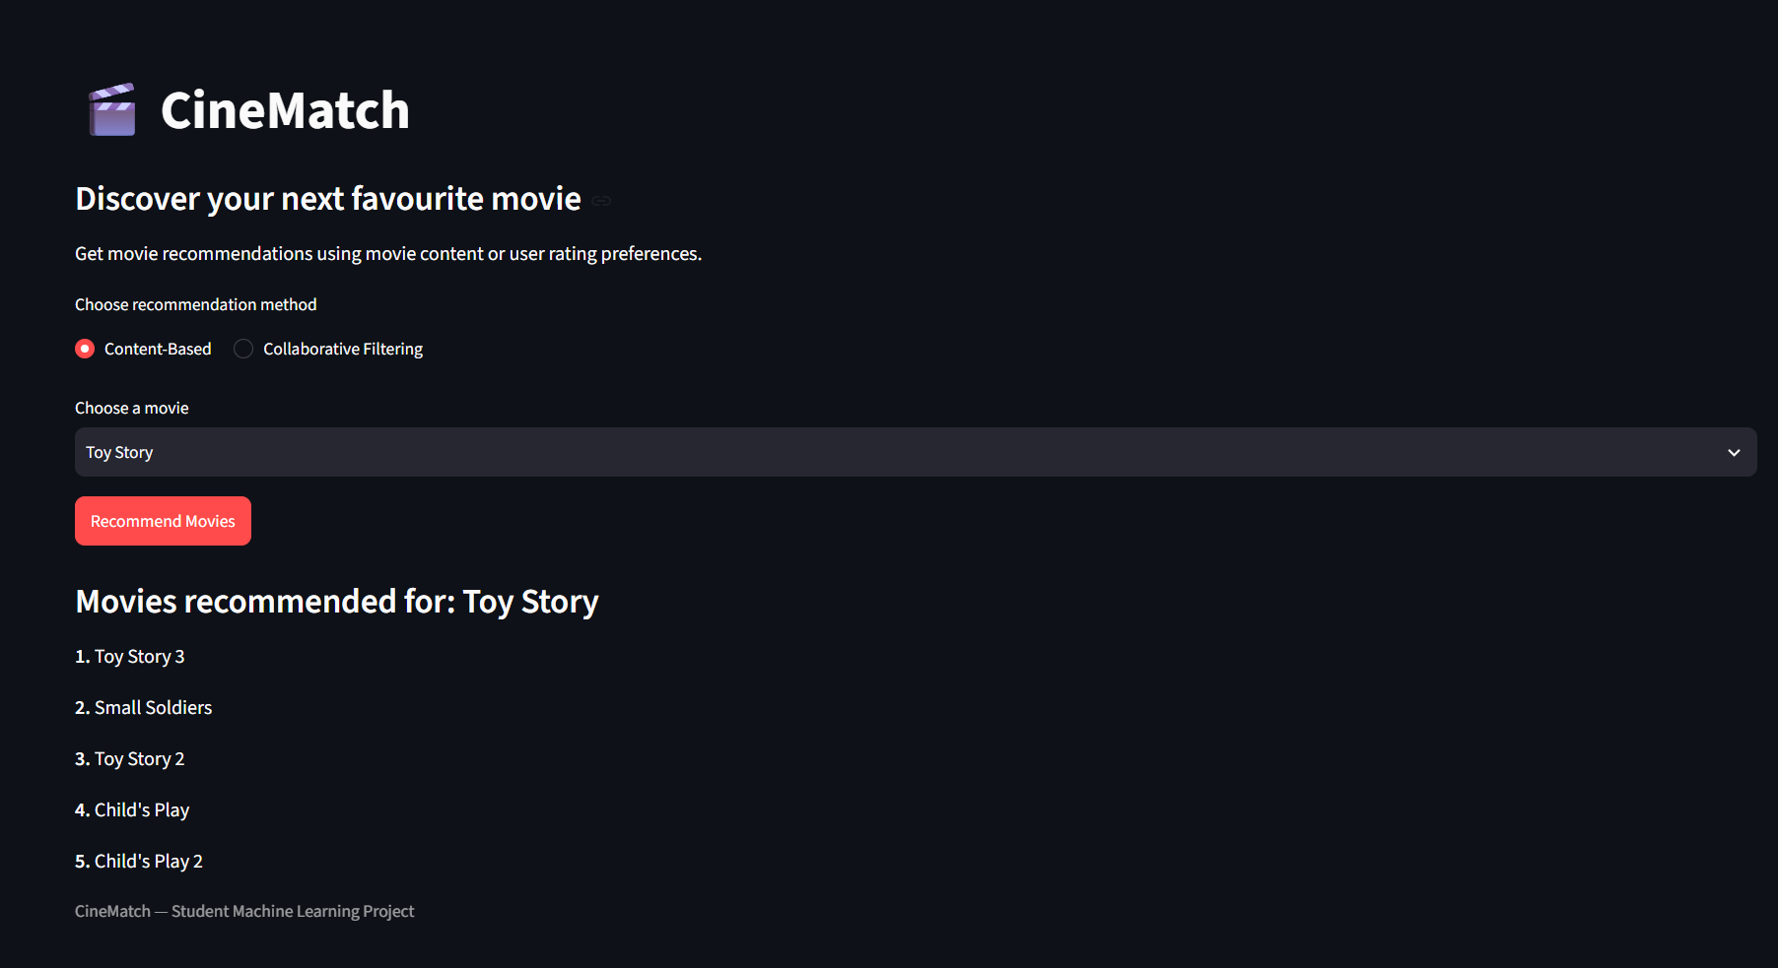

6. Conclusion
CineMatch demonstrates a movie recommendation workflow using two similarity-based approaches. Content-based filtering uses TF-IDF representations of movie metadata and cosine similarity to find films with similar descriptive features. Item-based collaborative filtering compares movies through historical user-rating patterns. The Streamlit interface lets users select a method and movie and view ranked suggestions. Development tests confirm that both components can return recommendations, while the examples also show limitations caused by keyword overlap and rating sparsity. The project provides a foundation for more rigorous evaluation and personalization.

7. Future Enhancements
- Add search-friendly input for the full movie list.
- Display posters, genres, release year, and short explanations.
- Tune content-feature weights and inspect similarity scores.
- Evaluate using held-out ratings and Precision@K, Recall@K, and NDCG@K.
- Explore matrix factorization such as SVD and a hybrid method.
- Handle title mismatches, missing data, cold-start movies, and duplicates.
- Cache models and calculate similarities on demand for better performance.
- Deploy online after checking dataset licensing and repository file sizes.

8. Team Contributions

Team Members
P. Yasasri (2520030373): content-based recommendation component, including movie metadata processing and similarity-based recommendation code and ppt.
G. Jahnavi (2520030483): collaborative filtering integration, Streamlit setup and testing, project integration, and report preparation.

9. References
1. scikit-learn documentation: TfidfVectorizer and cosine_similarity, https://scikit-learn.org/stable/.
2. Streamlit documentation, https://docs.streamlit.io/.
3. Pandas documentation, https://pandas.pydata.org/docs/.
4. TMDB 5000 Movies and Credits dataset, as obtained by the team; retain the original source and attribution information.
5. MovieLens dataset, as obtained by the team; retain the original source citation and usage terms.

Signature of the Team Members
P. Yasasri: ____________________ G. Jahnavi: ____________________

